Flare DMG Build Documentation
By Thomas Leavitt, thomas@thomasleavitt.org

About This Document
Version 1.0; documents version 1.0 MacOS release as built on a High Sierra 10.13.3 system in March of 2018.

Building the App
The Flare.app was manually constructed. The two folders are essentially identical, other than the Flare-engine.app not including the game mods: centered_statbars, empyrean_campaign, and fantasycore. The plist files Info.plist and InfoPlist.strings were derived from the versions included in the 0.19 DMG, with various modifications and updates. The Flare binary was copied from one generated from the 1.0 source code (with a minor modification) as sourced via git, and manually built as per instructions provided in the INSTALL.md folder for MacOS.

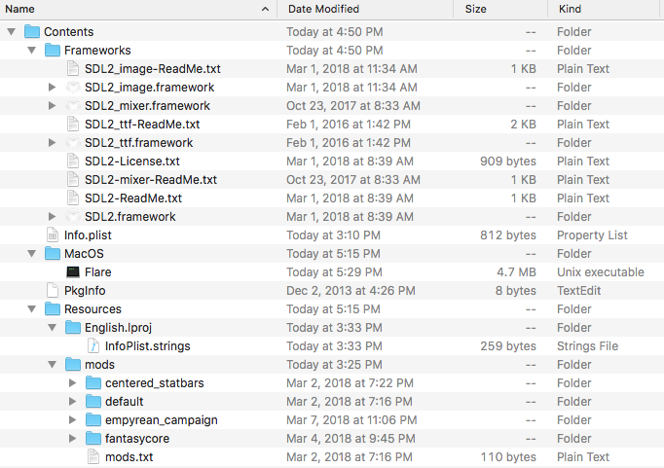
The contents of the Frameworks folder were derived from DMG images downloaded from the following locations, with the ReadMe.txt files renamed to be unique; these need to be stored in the app image as .frameworks folders as shown above:
- SDL_ttf 2.0 - https://www.libsdl.org/projects/SDL_ttf/
- SDL_mixer 2.0 - https://www.libsdl.org/projects/SDL_mixer/
- SDL_image 2.0 - https://www.libsdl.org/projects/SDL_mixer/
- SDL 2.0 - https://www.libsdl.org/download-2.0.php

The versions included are as listed below:

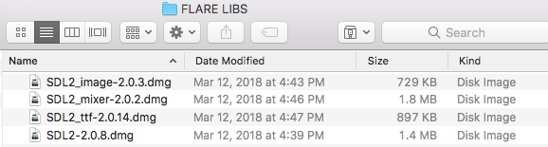

The listed DMGs have been uploaded alongside this document in the referenced “FLARE LIBS” folder.

Building the DMG
Two DMG images were built, one for Flare, and one for Flare-engine, as specified in the support thread, here:
Mac OS X maintainer #1583
https://github.com/clintbellanger/flare-engine/issues/1583

I pulled the image “empyrean_1-642x300.jpg” from the Flare web site (www.flarerpg.org), and then used “ProPaint” on my Mac to combine that with the logo image (flare_logo.svg) as sourced from the thread above, along with superimposing some basic text in the same color as the flare logo image (not sure how I derived that, TBH, it kind of happened automagically), to create the background image for the DMG. The resulting PSDB and file “flare_dmg_background.png” were used in conjunction with a simple shell script that leveraged an open source dmg creation script, “create-dmg” (https://github.com/andreyvit/create-dmg/) to build the DMG images themselves.
“create-dmg” was also used to enable the GPL license (in the form of the file COPYING) to be displayed as a “EULA” when the DMG images are opened.
I also used the logo image, in conjunction with the iConvert web site (https://iconverticons.com/online/) to create an iconset, which I then in turn used to create an icns file, which in turn was used in the create-dmg script as the icon for the DMGs when mounted as a volume:

$ iconutil -c icns flare.iconset
The psdb file (editable layered version), the iconset folder and the icns file, and the final version of the background png file, have been uploaded to the same shared Google Drive folder that the DMGs were shared through, along with this document, and the original folders from which the DMGs were built (as tgz files). These were built against the 1.0 version as tagged in Git, retrieved and sync’d via GitKraken 3.4, with a minor modification from that version in src/PlatformLinux.cpp to enable the application to properly derive the PATH info and be able to load the “mods” directory (as documented in the support thread above).

Here is the build script for the flare.dmg:
#!/bin/sh
/Users/tvleavitt/appdev/yoursway-create-dmg/create-dmg \
--volname "Flare" \
--volicon "/Users/tvleavitt/Downloads/flare.icns" \
--background "/Users/tvleavitt/Downloads/flare_dmg_background.png" \
--text-size 16 \
--window-size 642 320 \
--app-drop-link 300 125 \
--icon Flare.app 100 125 \
--hide-extension Flare.app \
--eula ../flare.dmg/COPYING \
flare.dmg \
../flare.dmg/
...and for flare-engine.dmg
#!/bin/sh
/Users/tvleavitt/appdev/yoursway-create-dmg/create-dmg \
--volname "Flare Engine" \
--volicon "/Users/tvleavitt/Downloads/flare.icns" \
--background "/Users/tvleavitt/Downloads/flare_dmg_background.png" \
--text-size 16 \
--window-size 642 320 \
--app-drop-link 300 125 \
--icon Flare-engine.app 100 125 \
--hide-extension Flare-engine.app \
--eula ../flare-engine.dmg/COPYING \
flare-engine.dmg \
../flare-engine.dmg/

Contents of DMG root folder for flare.dmg and flare-engine.dmg:
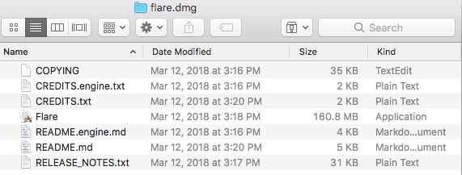
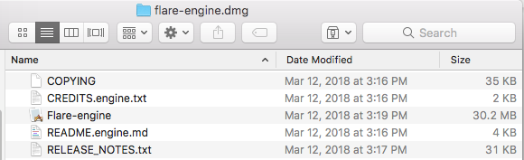

ToDo
The DMGs as generated have some minor issues:

- The ancillary text files are displayed as icons in the DMG window (COPYING) etc. are visible after scrolling to the right, but their icons and filenames all overlap into an unreadable hash. This may be correctable by putting these all in a folder, not sure; they can also be viewed by changing the view of the DMG itself to one that lists the content as files.
- The filenames displayed in the DMG for the Flare app and Flare-engine app are fuzzy and functionally unreadable, as is the name for the alias to Applications.
- The image itself is kind of hastily put together, a nicer pointer from the Flare.app icon to the Applications alias than “>>” should be created / located and integrated into the image.
- We could potentially include localizations for the plist file contents.

Issues with the Flare and Flare-engine apps:
- The Flare.app folder was manually built; we should look into redoing this so that it is built via cmake (or XCode if absolutely necessary) as part of the build process.
- We were unable to manually construct a .app folder image that permitted the app itself to display an icon in Finder (the .icns); it appears that some changes have been made that require source code modifications and/or the use of XCode (only method I could identify) to successfully do this; it is unclear whether this can be done with cmake. Simply putting the .icns in the root of the Resources folder did not work; neither did modifying the Info.plist file to reference the icon file or path to it. Apparently on High Sierra, there is an “Asset Catalog” that has to be created, and the location of the .icns file is derived from that. We may need to convert to a .pkg version to better deal with this.
- We may want to sign our code to avoid security warnings, and to enable distribution via the MacOS App Store.

